PVC電纜PVC Cable
圓形600V聚氯乙烯絕緣及被覆電纜-單芯
Circular 600 PVC Insulation and Jacket Cable Single Core

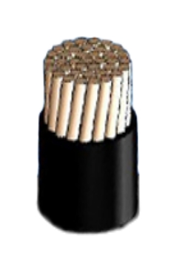Construction:
CONDUCTOR_BARE COPPER
JACKET_PVC

Conductor |  | Insulation thickness | Overall diameter (approx.) | max. Conductorresistance 20℃ | AC test voltage | min.Insulation  Resistance 20℃ | Weight  (約)  (approx.)
sq. mm. | No./mm
 |  | mm | mm | Ω/km | V/1min | MΩ-km | Kg/km
1.0 mm | 1/1.0 | 2.3 | 5.6 | 22.8 | 1500 | 50 | 40
1.2 mm | 1/1.2 | 2.3 | 5.8 | 15.8 | 1500 | 50 | 45
1.6 mm | 1/1.6 | 2.3 | 6.2 | 8.92 | 1500 | 50 | 60
2.0 mm | 1/2.0 | 2.3 | 6.6 | 5.65 | 1500 | 50 | 85
2.6 mm | 1/2.6 | 2.5 | 7.6 | 3.35 | 1500 | 50 | 105
3.5 mm² | 7/0.8 | 2.3 | 7.0 | 5.20 | 1500 | 50 | 85
5.5 mm² | 7/1.0 | 2.5 | 8.0 | 3.33 | 1500 | 50 | 115
8mm² | 7/1.2 | 2.7 | 9.0 | 2.31 | 1500 | 50 | 155
 | 壓縮  Compacted circular |  | 8.8 | 2.29 |  |  | 150
14 mm² | 7/1.6 | 2.9 | 11.0 | 1.30 | 2000 | 40 | 235
 | 壓縮  Compacted circular |  | 10.5 | 1.31 |  |  | 225
22 mm² | 7/2.0 | 3.1 | 12.5 | 0.0824 | 2000 | 40 | 335
 | 壓縮  Compacted circular |  | 12.0 | 0.0832 |  |  | 325
30mm² | 7/2.3 | 3.1 | 13.0 | 0.0623 | 2000 | 40 | 410
 | 壓縮  Compacted circular |  | 12.5 | 0.0610 |  |  | 400

